This term we will be exploring
Animal Adventures
through our key stories:
Personal, Social and Emotional Development
- I know who to ask for help in different situations,
- I will talk about and make healthy food choices,
- I can express how I feel when change happens,
- I can talk about worries and things to look forward to in year one.
Literacy
- In phonics, I will continue practising Level 3 phonemes and graphemes,
- I will read and write longer words including words with adjacent consonants and polysyllabic words,
- I will recognise and write tricky words we, he, me, be, she, my, you, was, they, all, are,
- To write short sentences using a capital letter, finger spaces and a full stop,
- I will recall and discuss stories or information,
- I will retell familiar stories using repeated refrains,
- Our Drawing Club key texts are: The Very Hungry Caterpillar, Norman the Slug with a Silly Shell, Superworm, The Ugly Five, Walking Through the Jungle, Growing Frogs.

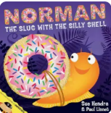
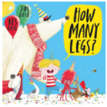
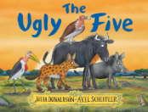

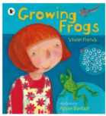
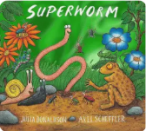
Communication and Language
- I will demonstrate good listening behaviours in a variety of situations,
- I will begin to understand humour eg. nonsense rhymes and silly stories,
- I will talk more extensively about things that are of particular importance to me,
- I will connect ideas using sequencing vocabulary: first, then, next, finally,
- I will understand and ask questions such as who; when; why; where and how.
Expressive Arts and Design
- I will explore the properties of clay and playdough,
- I will use modelling tools to cut and shape clay and playdough,
- I will talk about colour, shape and texture,
- I will share and evaluate my own work.
Understanding the World
- I will be able to recognise and talk about the key features of summer as I observe and explore the environment and the key story: Hello Summer,
- I will know the names of familiar animals and common body parts eg. legs, wings, fur, tail,
- I will know that animals live in different types of places eg. hot and cold,
- I will know where animals like minibeasts might be found on the school site.
- I will observe and draw animals in the environment,
- I will observe and draw plants in the immediate environment.

Maths
- I will subitise to 5,
- I will begin to learn how to use a rekenrek,
- I will have automatic recall of number bonds to 5,
- I will explore the composition of numbers to 10,
- I will compare numbers and explore number patterns,
- I will count numbers in order beyond 20,
- I will visualise, build and map.
Physical Development
- I will practise forming the ‘curly caterpillar family’ letters accurately (c, o, a, d, g, q)
- I will catch a ball by holding my arms out and pulling the ball into my body,
- I will catch a ball that has been bounced,
- I will throw a ball with accuracy to a peer will use a bat to hit a ball,
- I will kick a ball forward at a target.

